## Testing Classes & Pipes

**Learning Objectives**

• How to unit test an instance of a class.

 Everything in Angular is an instance of a class, be it a Component, Directive, Pipeand so on. So once you know how to test a basic class you can test everything.

Let’s imagine we have a simple class called AuthService it’s something we want to provide to Angulars DI framework but that doesn’t play a part in how we want to test it.

*app/auth.service.ts*

export class AuthService {

isAuthenticated(): boolean {

return !!localStorage.getItem('token');

}

}

It has one function called isAuthenticated which returns true if there is a token stored in the browsers localStorage.

To test this class we create a test file called auth.service.spec.ts that sits next to our auth.service.ts file, like so: *app/auth.service.spec.ts*

import {AuthService} from './auth.service';

①

describe('Service: Auth', () => {

②

})

;

1. We first import the AuthService class we want to run our tests against.
2. We add a describe test suite function to hold all our individual test specs.

**Setup & teardown**

We want to run our test specs against *fresh* instances of AuthService so we use the beforeEach and afterEach functions to setup and clean instances like so:

*app/auth.service.spec.ts*

describe('Service: Auth', () => {

let service: AuthService;

beforeEach(() => {

①

service = new AuthService();

});

afterEach(() => {

②

service = null;

localStorage.removeItem('token');

});

})

;

1. Before each test spec is run we create a new instance of AuthService and store on the service variable.
2. After each test spec is finished we null out our service and also remove any tokens we stored in localStorage.

**Creating test specs**

Now we create some test specs, the first spec I want to create should check if the isAuthenticated function returns true when there is a token.

it('should return true from isAuthenticated when there is a token', () => { ①

localStorage.setItem('token', '1234'); ②

expect(service.isAuthenticated()).toBeTruthy(); ③ });

1. We pass to the it function a human readable description of what we are testing. This is shown in the test report and makes it easy to understand what feature isn’t working.
2. We setup some *spec only* data in local storage which should trigger the effect we want.
3. We test an expectation that the service.isAuthenticated() function returns something that resolves to true.

We also want to test the reverse case, when there is no token the function should return false:

it('should return false from isAuthenticated when there is no token', () => {

expect(service.isAuthenticated()).toBeFalsy();

});

We *know* that in this function the token isn’t set since we make sure to clear out the token in the afterEach function.

We now test an expectation that the service.isAuthenticated() function returns something that resolves to false.

**Running the tests**

To run our tests we simply open up the HTML file in the browser, you can just click the plunker link and make sure to press run in the toolbar.

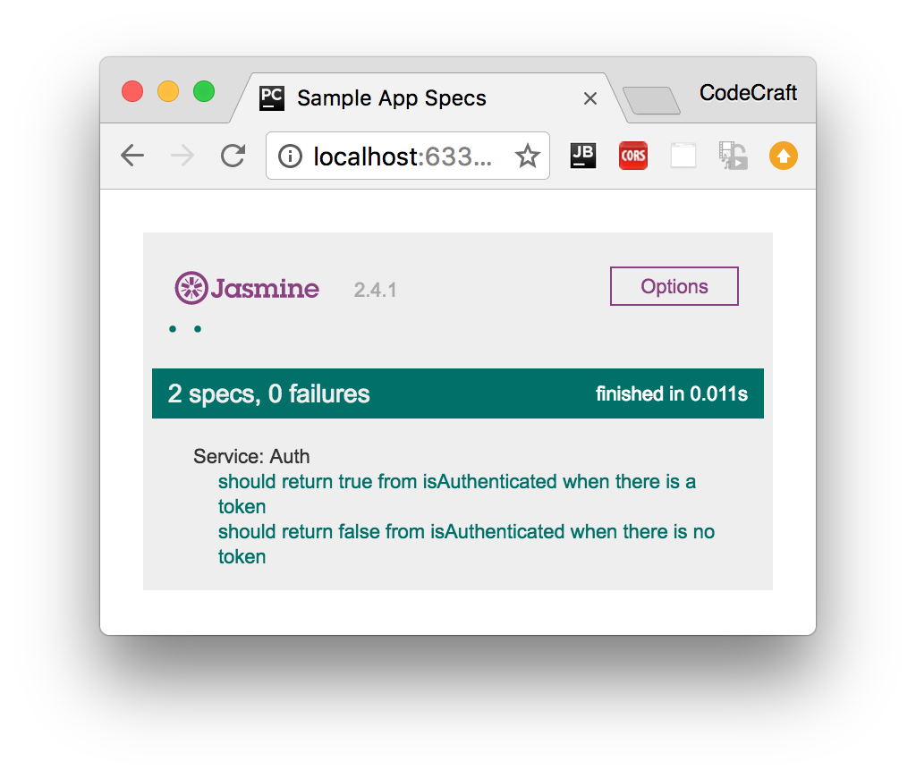

**Pipes**

Pipes are by far the simplest part of Angular, they can be implemented as a class with one function and therefore can be tested with *jus t* Jasmine and the knowledge we’ve gained so far.

In the section on pipes we built one called DefaultPipe, this pipe lets us provide default values for variables in templates like so:

{{

image | default:"http://example.com/default-image.png"

}}

The code for this pipe looked like so:

import {Pipe, PipeTransform} from '@angular/core';

@Pipe({

name: 'default'

})

export class DefaultPipe implements PipeTransform {

transform(value: string, fallback: string, forceHttps: boolean = false): string {

let image = "";

if (value) {

image = value;

} else {

image = fallback;

}

if (forceHttps) {

if (image.indexOf("https") == -1) {

image = image.replace("http", "https");

}

}

return image;

}

}

Our starting test suite file looks like so:

describe('Pipe: Default', () => {

let pipe: DefaultPipe;

beforeEach(() => {

pipe = new DefaultPipe();

});

})

;

In our setup function we create an instance of our pipe class.

Pipe classes have one function called transform so in order to test pipes we just need to test this one function, passing inputs and expecting outputs.

Our first test spec checks to see that if the pipe doesn’t recieve an input it returns the default value, like so:

it('providing no value returns fallback', () => {

expect(pipe.transform('', 'http://place-hold.it/300')).toBe('http://place-

hold.it/300');

})

;

We pass in empty string as the input to the transform function and therefore it returns the second argument back to us.

For testing pipes there isn’t much else to it, we simply check the various inputs and expected ouputs of our transform function.

In Inorder to run this test spec file in our test Plunker remember to add it to the listof test spec files in the spec_files array.

 If your *Pipe* requires dependencies to be injected into the constructor it might be better to use the *Angular Test Bed* which we cover later on in this section.

**Summary**

we can test any *isolated* class that doesn’t require anything else with a simple jasmine spec file, nothing more complex required.

Since everything in Angular is represented as classes, we could stop here - you have most of the tools already to write tests for directives, components, pipes and so on.

However our code often requires *other* code to work, it has dependencies. So how we write *isolated* tests for pieces of code which by nature are not isolated and need dependencies is the topic of the next lecture.

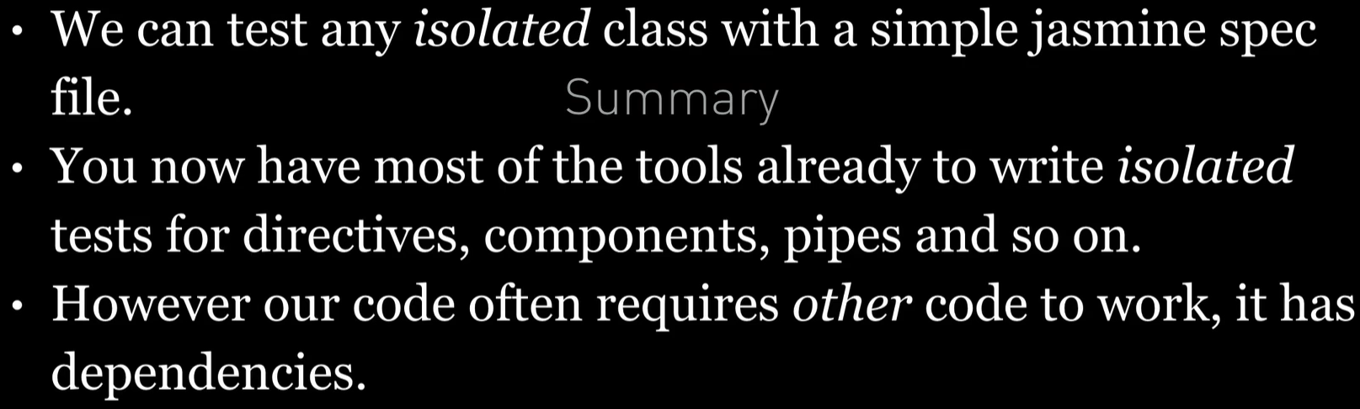

**Listing**

<http://plnkr.co/edit/5uULMJkAgug0e4iqnbi2?p=preview>